Functional connectivity dynamics differentiate subdivisions of precuneus

- Hypothesis
The whole brain functional connectivity of each subdivision of the precuneus will change over time, alternating between a finite number of “micro-states”. We propose that each subdivisions will posses a distinct microstate profile (e.g., number of states, state features, state-shifting pattern, duration of states).

B. Analysis procedures
1. Preprocessing
Chao-gan has preprocessed the first 5 min of session 1 and session 2 data for all 25 subjects.
The data I am going to use are: HeadMotionRegression_2Friston_24_COV_GloabalWS (motion corrected with Friston 24, global signal regressed out. W: normalized, S: smoothed).

2. ROI Time series extraction
a. Seed locations were determined based on Margulius et al. (2009). Representative seed regions.
Seed 4 (-2/-36/35): Located in the middle of the splenium in the y-axis, within the cingulate gyrus.
Seed 6 (-2/-47/58): Located at the center of the marginal ramus of the cingulate sulcus, 6 mm posterior to it.
Seed 14 (-2/-64/45): Located ventral to seed 13 along the sulcus.
Seed 17 (-1/-78/43): Located ~10 mm posterior to seed 13 and 6 mm anterior to the parietal-occipital sulcus.
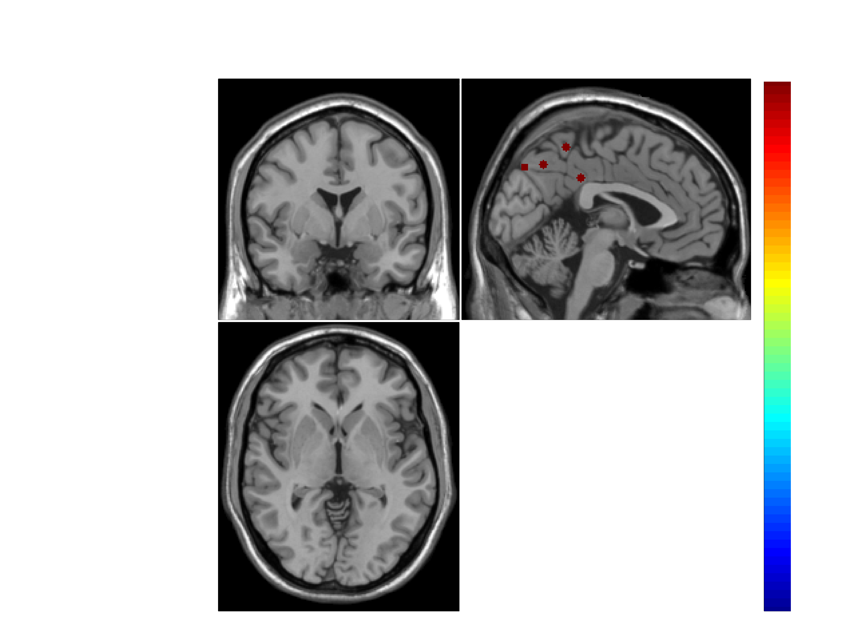

b. atlas selection:
Depend on which atlas can adequately remove the precuneus and PCC
** ROIs which overlap with precuneous and PCC were removed, leaving a total of ** ROIs for final analysis.
How to determine the overlap between these two regions and the atlas?
The atlas resolution?
Where to find the Crad-400?
connectivity atlas: Crad-200
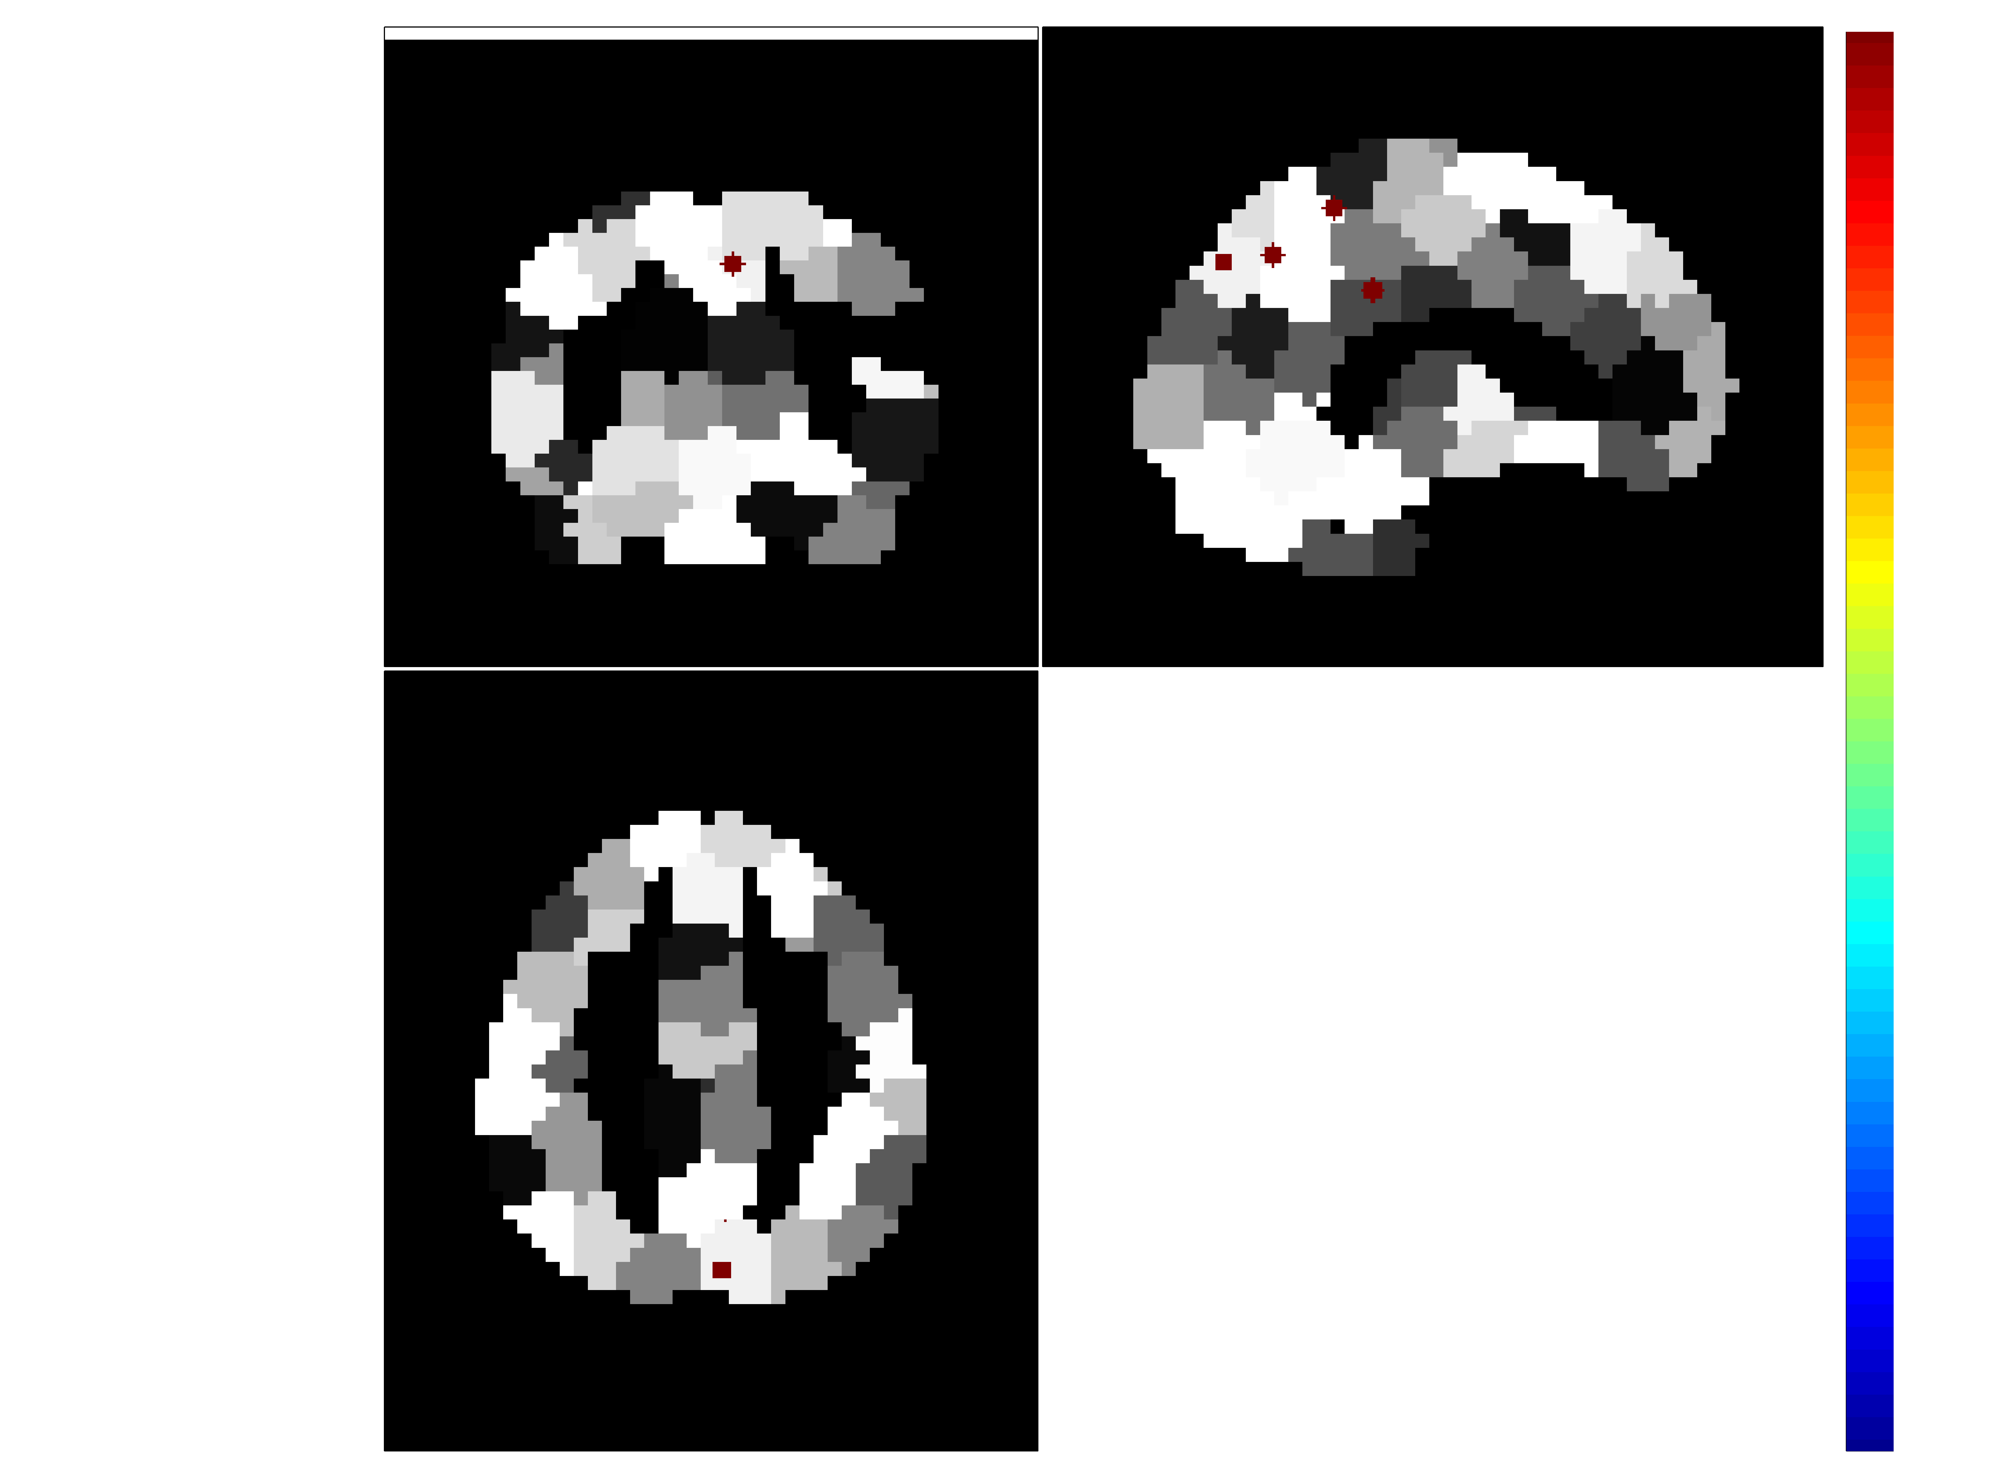

structrual atlas: Harvard-Oxford atlas 110 cortical regions
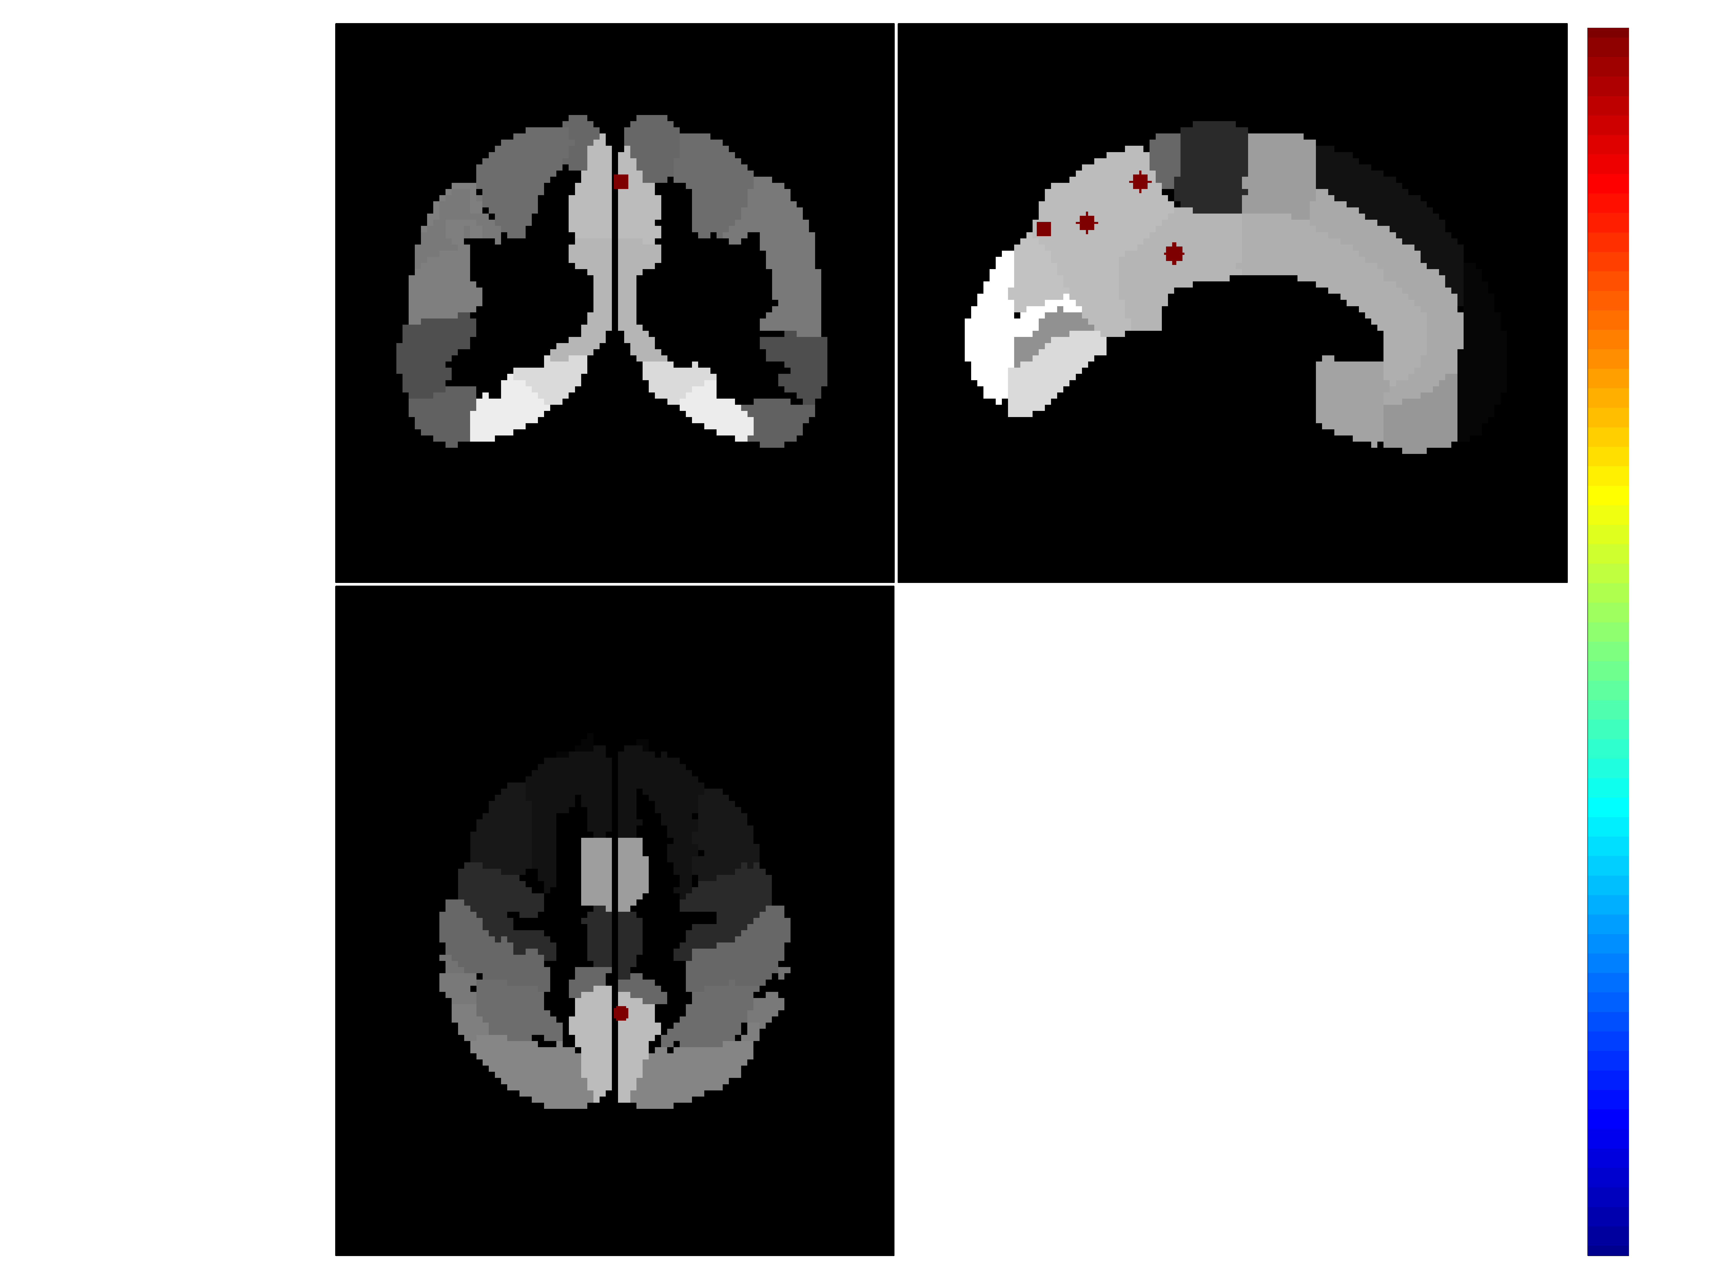

anatomic atlas: AAL
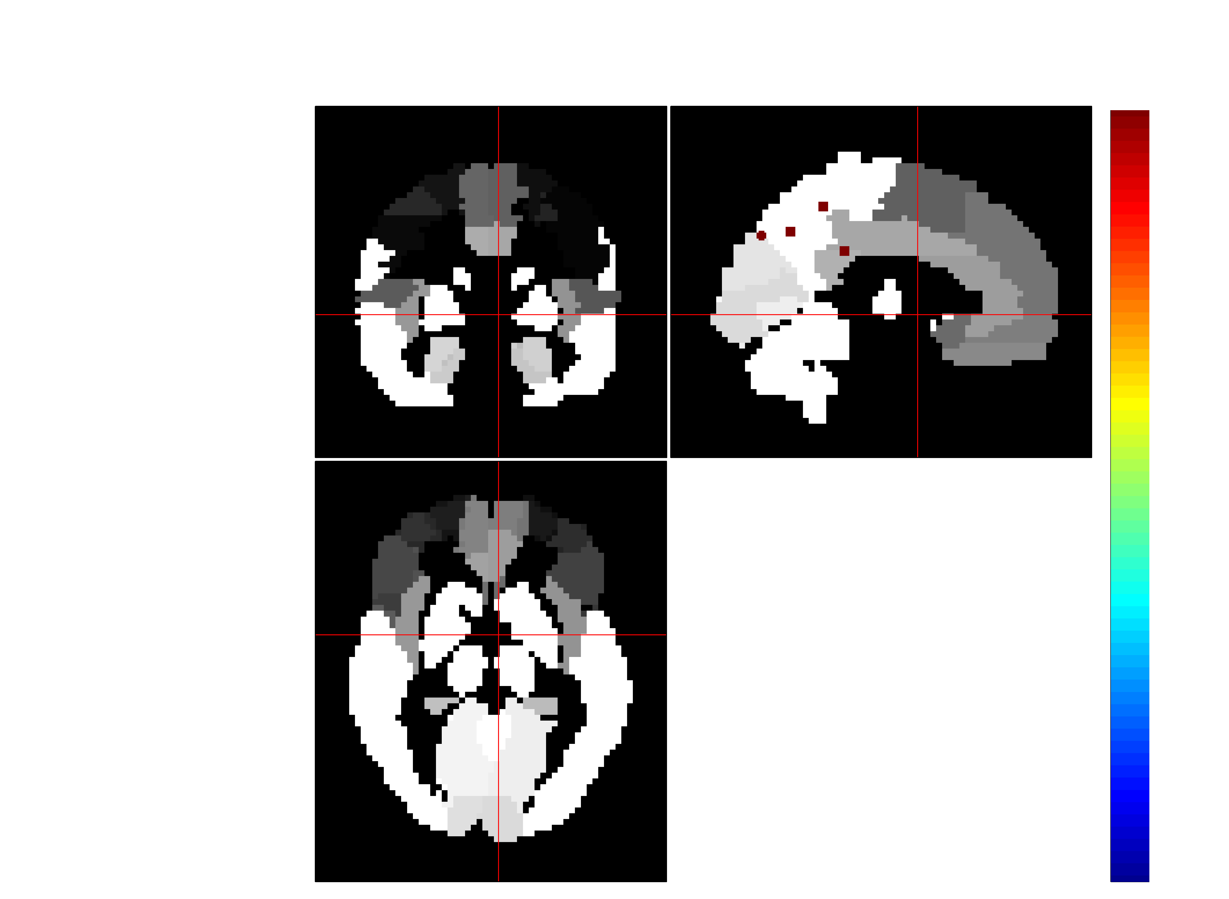
- Time series extraction:
Time series of each voxel was z-score normalized before extracting time series for ROIs.
Normalize spatially or temporally, for each single subject or across the group? Also, how to? If we don't use the maximal FC variance as a criteria to select exemplars, do we still need to normalize the time series?
The time series of 4 seeds and ** ROIs were extracted from the preprocessed 4D timeseries data in MNI space.
These time series were then concatenated to form a 450 x (4+**) matrix.

3. Stationary FC analysis using the full length of the time series
For each seed, preform the following analysis. Repeat a-c for seed 2-4.
- Calculate the covariance/correlation matrix
- Fisher transform the covariance matrix.
- Sort connections based upon lobar (i.e., frontal, temporal, parietal, occipital, subcortical) classifications and create a 1 x N correlation matrix. N is the number of ROIs.
Full correlation: regularized inverse or not? Test both

4. Dynamic FC estimation using time series within a sliding window:
Sliding window creation (Test a couple windows on clustering results)
- The window can be created by convolving a rectangle (width = 0.645 s *22 TRs ) with a Gaussian (and slide in steps of 1 TR, resulting in W= N-width+1 windows (Allen, et al., 2012).

Left: time series; Right: frequency responses
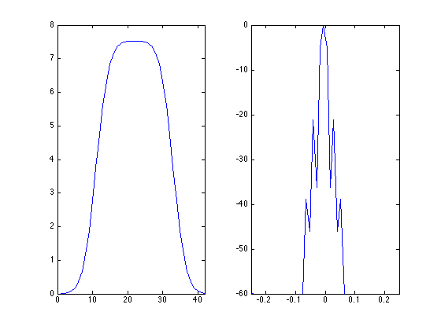

- rectangular window

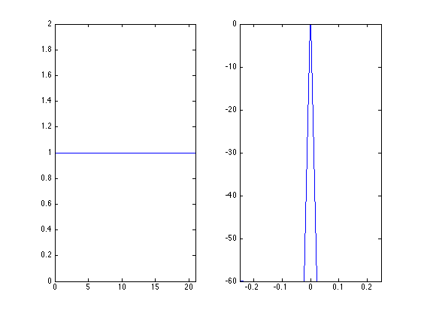
- Gaussian window
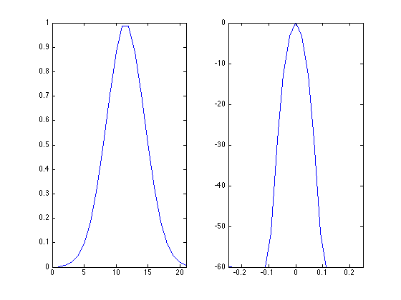
- Hanning
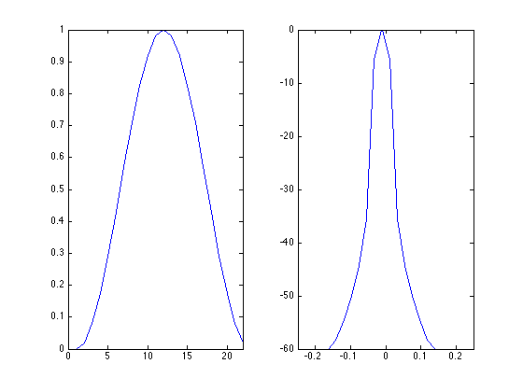
- Hamming window
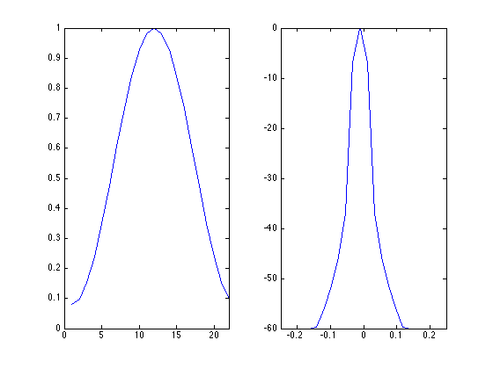
FC analysis for each sliding window
For each seed perform the following analysis and repeat a-e for seeds 2-4
- Apply the sliding window to the matrix containing the time series of 196 ROIs and the selected one seed
- Calculate the covariance matrix
- Calculate the regularized inverse covariance matrix
- Fisher transform the covariance matrix.
- Concatenate all windows
- plot the correlations between the seed and the significant ROIs as a function of time (each time point corresponding to the center of the window)
- plot the power spectral for the time series in c. fft
FC state identification using clustering analysis
FC state can be defined as highly structured patterns of FC that emerge and dissolve over tens of seconds (Allen et al., 2012). subsampling/initial clustering/secondary
>clustering approach
- choose exemplars defined as those windows with local maxima in FC for each subject. “FC variance is defined as the variance over the correlations.” is this the variance of all values in the covariance or regularized inverse of the covariance matrix?
- First clustering: apply K-means clustering algorithm to the set of exemplars from all subjects to obtain the group centroids. The number of clusters was determined using the elbow criterion of the cluster validity index, computed as the ratio between within-cluster distance to between-cluster distance.
- Second clustering: all windows were
assigned to the different states in second clustering step which used
the group centroids as the initial solution (a single clustering run).The centroids of a cluster putatively reflects a connectivity state stably present within the data.
- Repeat this clustering for 500 times to increase the chances of escaping local minima.
- Estimate the network modularity of each state by using the Louvain algorithm implemented in the Brain Connectivity Toolbox.
- Repeat the Louvain algorithm on 100 bootstrap resamples (resampling subject exemplars within each cluster) to obtain the occurrence trend and the best linear fit line.
- Plot the state transition examples for several subjects and compute the average transition matrix (TM). Approximate the stationary probability vector () as the principal eigenvector of the TM, which represents the expected behavior of the system in the long run.
6. Compare the number, feature, and duration of states among the 4 seeds
7. Calculate the test-retest reliability of the state analysis. This can be quantified as intra-class correlations on state measures between the data collected in session 1 and session 2.

